Background

# Contents

1. Medical context 3
   1. About cancer . . . . . . . . . . . . . . . . . . . . . . . . . . . . . . . . . . . . . . . . . . . . . . . . . 3

Cancer markers . . . . . . . . . . . . . . . . . . . . . . . . . . . . . . . . . . . . . . . . . . . . 3

Conditions leading to cancer . . . . . . . . . . . . . . . . . . . . . . . . . . . . . . . . . . . . 3

Phases of cancer . . . . . . . . . . . . . . . . . . . . . . . . . . . . . . . . . . . . . . . . . . . 3

Initiation . . . . . . . . . . . . . . . . . . . . . . . . . . . . . . . . . . . . . . . . . . . 3

Promotion . . . . . . . . . . . . . . . . . . . . . . . . . . . . . . . . . . . . . . . . . . . 3

Evolution . . . . . . . . . . . . . . . . . . . . . . . . . . . . . . . . . . . . . . . . . . . 3

Cancer stages . . . . . . . . . . . . . . . . . . . . . . . . . . . . . . . . . . . . . . . . . 3

Most common cancers . . . . . . . . . . . . . . . . . . . . . . . . . . . . . . . . . . . . . . . . 4

Risk factors . . . . . . . . . . . . . . . . . . . . . . . . . . . . . . . . . . . . . . . . . . . . . . 4

* 1. Treatment types . . . . . . . . . . . . . . . . . . . . . . . . . . . . . . . . . . . . . . . . . . . . . . . 4
     1. Surgery . . . . . . . . . . . . . . . . . . . . . . . . . . . . . . . . . . . . . . . . . . . . . . . . 4

Advantages . . . . . . . . . . . . . . . . . . . . . . . . . . . . . . . . . . . . . . . . . . 4

Disadvantages . . . . . . . . . . . . . . . . . . . . . . . . . . . . . . . . . . . . . . . . . 4

* + 1. Chemotherapy . . . . . . . . . . . . . . . . . . . . . . . . . . . . . . . . . . . . . . . . . . . . 4

Advantages . . . . . . . . . . . . . . . . . . . . . . . . . . . . . . . . . . . . . . . . . . 4

Disadvantages . . . . . . . . . . . . . . . . . . . . . . . . . . . . . . . . . . . . . . . . . 4

* + 1. Radiation therapy . . . . . . . . . . . . . . . . . . . . . . . . . . . . . . . . . . . . . . . . . . 4

Advantages . . . . . . . . . . . . . . . . . . . . . . . . . . . . . . . . . . . . . . . . . . 4

Disadvantages . . . . . . . . . . . . . . . . . . . . . . . . . . . . . . . . . . . . . . . . . 5

* + 1. Other treatments . . . . . . . . . . . . . . . . . . . . . . . . . . . . . . . . . . . . . . . . . . . 5

Immunotherapy . . . . . . . . . . . . . . . . . . . . . . . . . . . . . . . . . . . . . . . . . . . . 5

Targeted therapy . . . . . . . . . . . . . . . . . . . . . . . . . . . . . . . . . . . . . . . . . . . 5

Hormone therapy . . . . . . . . . . . . . . . . . . . . . . . . . . . . . . . . . . . . . . . . . . . 5

Stem cell transplant . . . . . . . . . . . . . . . . . . . . . . . . . . . . . . . . . . . . . . . . . 5

1. Physics of Radiotherapy 5
   1. Ionizing radiation . . . . . . . . . . . . . . . . . . . . . . . . . . . . . . . . . . . . . . . . . . . . . . . 5
   2. Photon interactions . . . . . . . . . . . . . . . . . . . . . . . . . . . . . . . . . . . . . . . . . . . . . . 5
      1. Rayleigh scattering . . . . . . . . . . . . . . . . . . . . . . . . . . . . . . . . . . . . . . . . . . 5
      2. Photoelectric absorption . . . . . . . . . . . . . . . . . . . . . . . . . . . . . . . . . . . . . . . 5
      3. Compton scattering . . . . . . . . . . . . . . . . . . . . . . . . . . . . . . . . . . . . . . . . . 6
      4. Pair production . . . . . . . . . . . . . . . . . . . . . . . . . . . . . . . . . . . . . . . . . . . . 6
   3. Photon attenuation . . . . . . . . . . . . . . . . . . . . . . . . . . . . . . . . . . . . . . . . . . . . . . 6
2. Biological e ect on cells 7
   1. Radiation e ects on DNA . . . . . . . . . . . . . . . . . . . . . . . . . . . . . . . . . . . . . . . . . . 7

DNA repair . . . . . . . . . . . . . . . . . . . . . . . . . . . . . . . . . . . . . . . . . . . . . . 7

* 1. Radiation a ects the plasma membrane . . . . . . . . . . . . . . . . . . . . . . . . . . . . . . . . . . 7
  2. Radiations and cell organelles performances . . . . . . . . . . . . . . . . . . . . . . . . . . . . . . . . 7
  3. Radiation alters the biological behavior of tumor cells and the immune system . . . . . . . . . . . . 8
  4. Radiation e ects when combined with immunotherapy . . . . . . . . . . . . . . . . . . . . . . . . . . 8

Ray-Enhanced Anti-CTLA-4 Immunotherapy . . . . . . . . . . . . . . . . . . . . . . . . . . . 8

Radiation Combined with Anti PD-1/PD-L1 Immunotherapy . . . . . . . . . . . . . . . . . . 8

TLR-Mediated Immunologic E ects of Radiation Therapy . . . . . . . . . . . . . . . . . . . . 8

1. Patient Path 8
   1. Diagnostic . . . . . . . . . . . . . . . . . . . . . . . . . . . . . . . . . . . . . . . . . . . . . . . . . . . 9
   2. Radiotherapy Prescription . . . . . . . . . . . . . . . . . . . . . . . . . . . . . . . . . . . . . . . . . . 9
   3. CT scan and Contouring . . . . . . . . . . . . . . . . . . . . . . . . . . . . . . . . . . . . . . . . . . . 9
   4. Treatment Planning . . . . . . . . . . . . . . . . . . . . . . . . . . . . . . . . . . . . . . . . . . . . . 9
   5. Irradiation Sessions . . . . . . . . . . . . . . . . . . . . . . . . . . . . . . . . . . . . . . . . . . . . . . 9
   6. Follow-up . . . . . . . . . . . . . . . . . . . . . . . . . . . . . . . . . . . . . . . . . . . . . . . . . . . 9
2. Machines 9
   1. Molds . . . . . . . . . . . . . . . . . . . . . . . . . . . . . . . . . . . . . . . . . . . . . . . . . . . . . 9
   2. MLC-LINAC . . . . . . . . . . . . . . . . . . . . . . . . . . . . . . . . . . . . . . . . . . . . . . . . . 10
   3. Tomotherapy . . . . . . . . . . . . . . . . . . . . . . . . . . . . . . . . . . . . . . . . . . . . . . . . . 10
   4. CyberKnife . . . . . . . . . . . . . . . . . . . . . . . . . . . . . . . . . . . . . . . . . . . . . . . . . . 10
   5. Brachytherapy . . . . . . . . . . . . . . . . . . . . . . . . . . . . . . . . . . . . . . . . . . . . . . . . 10
3. Irradiations techniques 11
   1. 3D-CRT . . . . . . . . . . . . . . . . . . . . . . . . . . . . . . . . . . . . . . . . . . . . . . . . . . . . 11
   2. IMRT . . . . . . . . . . . . . . . . . . . . . . . . . . . . . . . . . . . . . . . . . . . . . . . . . . . . . 11

Number of Beams . . . . . . . . . . . . . . . . . . . . . . . . . . . . . . . . . . . . . . . . . . 11

* 1. VMAT . . . . . . . . . . . . . . . . . . . . . . . . . . . . . . . . . . . . . . . . . . . . . . . . . . . . . 11

1. Dosimetry steps 11
   1. BOO . . . . . . . . . . . . . . . . . . . . . . . . . . . . . . . . . . . . . . . . . . . . . . . . . . . . . . 11
   2. FMO . . . . . . . . . . . . . . . . . . . . . . . . . . . . . . . . . . . . . . . . . . . . . . . . . . . . . . 12
   3. LS . . . . . . . . . . . . . . . . . . . . . . . . . . . . . . . . . . . . . . . . . . . . . . . . . . . . . . . 12

S&S . . . . . . . . . . . . . . . . . . . . . . . . . . . . . . . . . . . . . . . . . . . . . . . . . . 12

SW . . . . . . . . . . . . . . . . . . . . . . . . . . . . . . . . . . . . . . . . . . . . . . . . . . 12

* 1. DAO . . . . . . . . . . . . . . . . . . . . . . . . . . . . . . . . . . . . . . . . . . . . . . . . . . . . . . 14

1. Simulation 14
2. Treatment Planning Systems 16
   1. Manufacturer . . . . . . . . . . . . . . . . . . . . . . . . . . . . . . . . . . . . . . . . . . . . . . . . . 16

Eclipse (Varian) . . . . . . . . . . . . . . . . . . . . . . . . . . . . . . . . . . . . . . . . . . . 16

ONEfi | Planning (Elekta) . . . . . . . . . . . . . . . . . . . . . . . . . . . . . . . . . . . . . 16

Precisionfi (Accuray) . . . . . . . . . . . . . . . . . . . . . . . . . . . . . . . . . . . . . . . . 17

* 1. Non-manufacturer . . . . . . . . . . . . . . . . . . . . . . . . . . . . . . . . . . . . . . . . . . . . . . 17

RayStation (RaySearch) . . . . . . . . . . . . . . . . . . . . . . . . . . . . . . . . . . . . . . . 17

matRad (German Cancer Research Center - DKFZ) . . . . . . . . . . . . . . . . . . . . . . . 17

AutoPlan (TheraPanacea - Unpublished) . . . . . . . . . . . . . . . . . . . . . . . . . . . . . 17

Abstract

The background chapter of this PhD provides a comprehensive overview of key concepts in cancer treatment and radiotherapy. If you already know about radiotherapy and multi-leaf collimator, I strongly advise to skip this chapter.

This chapter begins by outlining the nature of cancer, its phases, stages, risk factors, and common types of treatments (with their advantages and disadvantages). Then, the physics of radiotherapy is explored, with a focus on ionizing radiation, and biological e ects of radiation. This chapter also presents the patient journey in radiotherapy, from diagnosis and treatment prescription to planning and follow-up. Key technologies used in radiation therapy, such as multi-leaf collimator (MLC) linear accelerator (LINAC) are introduced. Lastly, this chapter covers the irradiation techniques, and details major steps in the dosimetry process: beam orientation optimization (BOO), uence map optimization (FMO), leaf sequencing (LS), and direct aperture optimization (DAO).

# 1 Medical context

This PhD thesis is about radiation therapy (RT) for cancer treatment.

## 1.1 About cancer

Cancer is a complex disease that can affect many parts of the body, and is a leading cause of death worldwide. Cancer is characterized by the uncontrolled growth of cells that can invade and destroy surrounding tissues. The World Health Organization (WHO) estimated 20 million new cancer cases in 2022, and 9.6 million deaths linked to cancer in 2022 [who]. Cancer touches about 20% of the population, and is responsible for 1 in 10 deaths.

**Cancer markers** There are several cancer markers. Cancer cells proliferate uncontrollably. They also reprogram cellular metabolism to support their growth [CAG13]. They can also stop cell growth arrest mechanisms. They usually manage to evade apoptosis (programmed cell death). Cancer cells can escape the immune system, and change their cellular response phenotypic via plasticity. At some point, cancer cells can get the ability to undergo a suffcient number of successive cell cycles of growth and division to generate macroscopic tumors. To support their growth, they create new blood vessels to get nutrients. Finally, they can escape and form metastasis, and will eventually provoke senescence.

**Conditions leading to cancer** Cancer is a complex disease. First, cancer is caused by mutations in the DNA. These mutations can be inherited or acquired. Second, cancer is embraced by epigenetic reprogramming, i.e., gene expression changes (not caused by changes in the DNA sequence). Third, cancer is often associated with an in ammatory context; in ammation can promote cancer growth and spread. Finally, cancer is often associated with a disruption of the microbiota (the microbial community living in and on the human body). This disruption can promote cancer growth and spread.

**Phases of cancer** Cancer develops in several phases.

**Initiation** The first phase is initiation: a normal cell is transformed into a cancer cell. Mutations in the DNA cause this transformation.

**Promotion** The second phase is promotion or "tumorigenesis". During this phase, the cancer cell grows and divides uncontrollably to form a tumor cluster of cells. This growth is promoted by changes in gene expression and other factors [WSY10]. It may also create new blood vessels to get nutrients and oxygen.

**Evolution** The final phase is evolution. The tumor will first grow locally, then regionally, invading and damaging surrounding tissues. Finally, the cancer cell will spread to other body parts, forming metastasis. Metastasis is the leading cause of death in cancer patients [Ste06].

**Cancer stages** Cancer is classified into stages [can].

Stage 0: ’in situ neoplasm’; it means a group of abnormal cells in an area of the body. The cells may develop into cancer in the future.

Stage 1: the cancer is small and contained within the organ it started in.

Stage 2: the tumor is larger than in stage 1, but the cancer hasn’t started to spread into the surrounding tissues.

Stage 3: the cancer is larger; it has started to spread into surrounding tissues and cancer cells in the lymph nodes nearby.

Stage 4: the cancer has spread from where it started to another body organ. This spread is also called secondary or metastatic cancer.

Doctors use the TNM system to describe the cancer stage [JDB].

T stands for the size of the Tumour; It can be 1, 2, 3, or 4, with one being small and four being large.

N stands for the number of lymph Nodes affected; It can be between 0 and 3. 0 means no lymph node contains cancer cells; 3 means many lymph nodes contain cancer cells.

M stands for the existence of metastasis in another part of the body. It can be 0 (no spread) or 1 (the cancer has spread).

**Most common cancers** According to the WHO, the most common cancers are lung, breast, colorectal, prostate, skin, and stomach cancer. This thesis mainly focuses on prostate cancerwhich is among the most common ones.

**Risk factors** Tobacco use, alcohol consumption, unhealthy diet, physical inactivity, and air pollution are risk factors for other cancer types. However, the leading risk factor for prostate cancer is age. Thus, it touches all social populations evenly and is unavoidable.

## 1.2 Treatment types

There are three main types of cancer treatment: surgery, radiation therapy, and chemotherapy. The choice of treatment depends on the type and stage of cancer, the patient’s age and general health, and other factors.

1.2.1 Surgery

Surgery is the most effective cancer treatment [KCKM09]. It involves removing the tumor and surrounding tissue. Surgery is often used to treat early-stage cancer that has not spread to other parts of the body. For surgery to be possible, the tumor must be located in a place the surgeon can easily access. Surgery can be followed by other treatments, such as radiation therapy or chemotherapy, to kill any remaining cancer cells.

**Advantages** Surgery is curative, meaning that cancer is completely removed, and the patient can "forget" about it. It is also a local treatmentwith limited side effects on the body. Finally, only one session is needed.

**Disadvantages** Surgery is invasive, and it can be painful. The main disadvantage is that it can only be used for localized cancer (with no metastasis) accessible to the surgeon.

1.2.2 Chemotherapy

Chemotherapy is a treatment that uses drugs to kill cancer cells. It is systemic, meaning it can reach cancer cells anywhere in the body. Therefore, it usually has strong side effects. Chemotherapy is often used to treat cancer that has spread to multiple parts of the body (i.e., metastatic cancer).

Depending on how advanced the cancer is, chemotherapy can be used to cure, control, or relieve symptoms (palliation).

**Advantages** Chemotherapy can be used to treat cancer that has spread to multiple parts of the body. It can also be used to relieve symptoms and improve quality of life.

**Disadvantages** Chemotherapy is a heavy treatment with strong side effects. It can also weaken the immune system, making the patient more susceptible to infections. Finally, it can be expensive.

1.2.3 Radiation therapy

Radiation therapy is a treatment that uses high-energy radiation to kill cancer cells. It is semi-local, meaning that it only affects the tumor, and the tissues traversed by the radiation beams [THLSM+13]. Radiation therapy is curative most of the time. It can be used alone or in combination with other treatments.

Radiation therapy can be delivered in two ways: external radiation therapy and internal radiation therapy. External radiation therapy uses a machine to deliver radiation to the tumor from outside the body. Internal radiation therapy uses radioactive materials placed directly into or near the tumor. This thesis focuses on external radiation therapy.

**Advantages** Radiation therapy is a non-invasive treatment, with limited side e ects. It is relatively localized, and can be used to treat cancers that are not accessible via surgery.

**Disadvantages** Radiation therapy still targets healthy cells. Depending on the patient’s response, it may cause side effects.

1.2.4 Other treatments

Cancer research is very active, and new treatments are constantly being developed. These treatments are often used in combination with others.

**Immunotherapy** Immunotherapy is a treatment that uses the body’s immune system to fight cancer. It can boost or change how the immune system works to find and attack cancer cells. It is a systemic treatment.

**Targeted therapy** Targeted therapy is a treatment that uses drugs to target specific molecules that are involved in cancer growth. It is a systemic treatment.

**Hormone therapy** Hormones are proteins or substances the body makes that help control how specific cell types work. Hormone therapy is a treatment that uses drugs to block or lower the amount of hormones in the body that are involved in cancer growth. It is a systemic treatment.

**Stem cell transplant** A stem cell transplant is a treatment that uses stem cells to replace cells damaged or destroyed by cancer treatment. It is a systemic treatment.

# 2 Physics of Radiotherapy

Radiation therapy uses high-energy radiation to kill cancer cells.

## 2.1 Ionizing radiation

Ionizing radiation has enough energy to remove tightly bound electrons from atoms, creating ions. X-rays and gamma rays are both electromagnetic radiations that are ionizing and high-energy photons. Some particle radiations, such as particles, beta particles, and neutrons, are also ionizing, but radiotherapy uses photon radiations.

X-rays are produced by accelerating electrons to collide with a target material and are used in medical imaging and (external) radiation therapy. In contrast, gamma rays originate from the radioactive decay of specific atomic nuclei and are used in (internal) radiation therapy.

Because ionizing radiation therapy can damage the DNA in cells and lead to cell death, it is used in radiation therapy for treating cancer.

## 2.2 Photon interactions

Photon-matter interactions within an absorbing medium undergo stochastic processes. Four types of interactions ( Figure 1) are possible for photons; their occurrence depends on the atomic number, matter, and the energy of the incident photon [Eva58]. Three of the four interactions generate secondary ionizing particles that deposit energy in the medium.

2.2.1 Rayleigh scattering

The Rayleigh scattering (figure 1a) does not change the energy of the incident photons and consequently has no direct consequence on the body. Rayleigh scattering predominantly occurs with low-energy photons (typically *<* 100 keV).

2.2.2 Photoelectric absorption

The photoelectric absorption effect (figure 1b) is the process by which an atom absorbs a photon, and an electron is ejected from the atom. The photon ceases to exist, and its energy is transferred to the electron. The ejected electron, called a photoelectron, can ionize other atoms, leading to dose deposition. The photoelectric effect is the dominant interaction for low-energy (*<* 100 keV) photons.

|  |  |
| --- | --- |
| **Atom** |  |
| (a) Diagram of Rayleigh Di usion. | (b) Diagram of Photoelectric Absorption. |

**Scattered**

**Photo-Electron**

**Incident**

**Photon**

## **Atom**

**Photon**

**Incident**

**Photon**

**Atom**

**Campton**

**Electron**

**Incident**

**Photon**

**Scattered**

**Photon**

**Electron**

**Positron**

**Incident**

**Photon**

**Atom**

**Photon**

**Photon**

(c) Diagram of Compton Scattering. (d) Diagram of Pair Production.

Figure 1: Diagrams of photon interactions with matter observed in the kilo and mega-voltage energy range.

2.2.3 Compton scattering

Compton scattering (figure 1c) is the process by which an atom scatters a photon, and ejects an electron from the atom. The photon is scattered at an angle, and part of its energy is transferred to the electron. The emitted electron is called a Compton electron, which can ionize other atoms, leading to dose deposition. Compton scattering is the dominant interaction for medium-energy (≈ 0*.*1 to ≈ 10 MeV) photons.

2.2.4 Pair production

Pair production (figure 1d) is when an atomic nucleus absorbs a photon and creates an electron-positron pair. The photon ceases to exist, and its energy is transferred to the electron-positron pair. The positron rapidly interacts with another electron of the matter, producing two photons emitted at 180 from each other. The electron can ionize other atoms, leading to dose deposition. Pair production is the dominant interaction for high-energy (*>* 10 MeV) photons.

### 2.3 Photon attenuation

The photon beam will be attenuated as it passes through the medium, and its intensity will decrease. The dose deposition in the medium is proportional to the intensity of the photon beam. The attenuation of the beam follows an exponential law concerning the depth of the medium traversed (Lambert-Beer law) [Bee52]:

*I*(*x*) = *I*0exp(−*µx*)

Session 1

Session 2

Session 3

Session 4

Session 5

Time

0

1

/

4

1

/

2

3

4

/

1

DNA Quality

Healthy cell

Tumor cell

Figure 2: Quality of the the DNA in healthy and tumor cell after radiotherapy sessions.

where *I* is the intensity of the photon beam after passing through a thickness *x* of the medium, *I*0 is the initial intensity of the photon beam, and *µ* is the attenuation coe cient of the medium.

# 3 Biological effect on cells

Ionizing radiation can damage the cells leading to cell death in various ways.

## 3.1 Radiation e ects on DNA

Ionizing radiation damages the DNA [Sch14] in cells and leads to cell apoptosis, necrosis, or senescence. Radiation induces DNA damage through both direct and indirect mechanisms: Directly, it causes single-strand breaks (SSBs), double-strand breaks (DSBs) [RKG85], DNA crosslinks, and DNA-protein crosslinks [NXS+17]. Indirectly, radiation generates reactive oxygen species (ROS) and reactive nitrogen species (RNS), further contributing to DNA damage.

**DNA repair** Cells have mechanisms to repair DNA damage. There are several types of DNA repair mechanisms, including base excision repair (BER), nucleotide excision repair (NER), mismatch repair (MMR), and double-strand break repair (DSBR). Cancer cells often have defects in DNA repair mechanisms, making them more sensitive to radiation therapy [JDB]. This repair mechanism being available only for healthy cells leads to cell death only for cancerous cells when their DNA is too damaged to survive (see figure 2).

## 3.2 Radiation affects the plasma membrane

Radiation significantly impacts the biological properties of the plasma membrane by affecting its composition, structural integrity, and functional capabilities. Radiation exposure can alter the fluidity and permeability of the cell membrane, affecting the transport of ions and molecules into and out of the cell. Additionally, radiation causes corrosive damage, and damage to the membrane can initiate signaling events that are important for the apoptotic response [CBM99]. These changes can have cascading effects on various cellular processes, highlighting the critical role of the plasma membrane in maintaining cellular homeostasis under stress conditions.

## 3.3 Radiations and cell organelles performances

Radiation exerts significant detrimental effects on various cellular organelles impacting their functionality and overall cellular health [Som00]. One critical target of radiation damage is the endoplasmic reticulum where radiation can disrupt protein folding and processing, leading to cellular stress and apoptosis. Additionally, ionizing radiation induces alterations in ribosomal structure and function, impairing protein synthesis and compromising cellular homeostasis. Mitochondria, the cell’s powerhouses, also exhibit altered behavior following radiation exposure, including disruptions in energy production and initiating apoptotic pathways. Furthermore, lysosomes, essential for cellular waste processing and recycling, suffer damage upon irradiation, potentially accumulating cellular debris and impairing cell function. These collective effects highlight radiation’s broad and profound impact on cellular organelle performance [WWQ18].

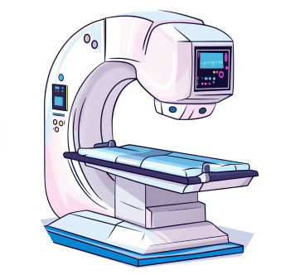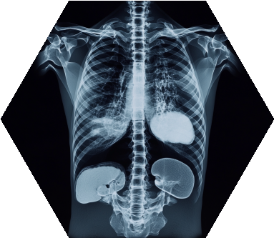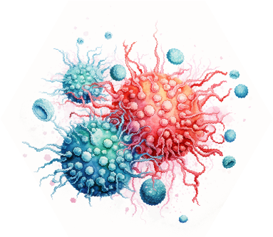

**Cancer**

**Diagnostic**

**Radiotherapy**

**Prescription**

**CT Scan &**

**Contouring**

**Treatment**

**planning**

**Irradiation**

**Sessions**

Figure 3: Typical radiotherapy patient path.

## 3.4 Radiation alters the biological behavior of tumor cells and the immune system

Radiation profoundly influences the biological behavior of tumor cells and the immune system, impacting critical aspects of cancer progression and immune response. It affects tumor cell proliferation, often reducing the ability of cancer cells to multiply by damaging their DNA and cellular structures. Radiation also influences tumor cells’ invasion and metastasis potential either by directly impairing their motility or altering the tumor microenvironment to make it less conducive to cancer spread. Additionally, radiation can modulate cancer-promoting inflammation, either by inducing pro-inflammatory signals that support tumor growth or by disrupting the inflammatory milieu to hinder cancer progression.

## 3.5 Radiation effects when combined with immunotherapy

Radiation may support immunotherapy making the effect of both treatments more significant than the sum of their impact if used alone.

**Ray-Enhanced Anti-CTLA-4 Immunotherapy** Radiation therapy can enhance the efficacy of anti-CTLA-4 immunotherapy, a treatment that blocks the CTLA-4 protein in T cells, thus boosting the immune system’s response against cancer cells. The combination of radiation and anti-CTLA-4 immunotherapy has shown promising results, as radiation-induced tumor cell death releases antigens that can further stimulate the immune system [VBPW+15]. This synergy can improve tumor control and potentially better clinical outcomes than either treatment alone.

**Radiation Combined with Anti PD-1/PD-L1 Immunotherapy** Combining radiation with anti PD-1/PDL1 immunotherapy has shown significant success. Anti PD-1/PD-L1 therapies block the PD-1/PD-L1 pathway which tumors exploit to evade immune detection. Radiation therapy can augment this effect by increasing the immunogenicity of the tumor, thereby making cancer cells more susceptible to immune attack [HXL+21].

**TLR-Mediated Immunologic Effects of Radiation Therapy** Radiation therapy can also exert immunologic effects through Toll-like receptors (TLRs), a class of proteins involved in pathogen recognition and activation of innate immunity. Radiation can activate TLRs on immune cells, producing cytokines and chemokines that enhance the immune response against tumors. This TLR-mediated effect contributes to the synergy between radiation and immunotherapies, leading to more robust anti-tumor responses [WHCI20].

While this thesis does not focus on biological aspects, one should remember that radiation affects cells in various ways, and cancer therapy is complex.

# 4 Patient Path

The radiotherapy patient path encompasses several critical stages, each essential for the effective treatment of cancer. This section outlines the sequential steps of radiotherapy, from initial detection and diagnosis to follow-up care.

## 4.1 Diagnostic

Patients diagnosed with a tumor can go through several paths: surgery, radiotherapy, immunotherapy, chemotherapy, or any combination. Doctors will choose the most appropriate treatment(s) based on evidence they have (biopsy, radios, et cetera). This manuscript will focus on the radiotherapy path.

## 4.2 Radiotherapy Prescription

Following a confirmed diagnosis and the choice of radiotherapy treatment, the oncologist develops a prescription. This prescription specifies the type, dosage, and frequency of radiation treatment tailored to the patient’s specific cancer type, location, and stage. The doctors define minimal tumor irradiation and maximum damage to surrounding healthy tissues. Most of the time, templates are used and ne-tuned to t specific patients.

## 4.3 CT scan and Contouring

A computed tomography (CT) scan is performed to obtain detailed images of the patient’s anatomy. These images are used to delineate the tumor and surrounding organs at risk. The contouring task used to be a manual operation but is now done automatically, thanks to the progress of artificial intelligence on segmentation tasks. The CT scan also provides the spatial information necessary for precise irradiation simulation.

## 4.4 Treatment Planning

The treatment planning process involves developing a detailed plan specifying the patient’s radiation dose distribution. Advanced software calculates the optimal arrangement of radiation beams to achieve the desired dose while minimizing exposure to healthy tissues. This thesis registers new advances in the planning step. Plans must be reviewed and approved by doctors.

## 4.5 Irradiation Sessions

Irradiation sessions, or treatment delivery, is the actual irradiation of the patient. Cone Beam Computed Tomography (CBCT) is usually done to reposition the patient with the scan so that all organs align with the planning CT. Nowadays, the tendency is to reduce the number of irradiation sessions (the old typical five weeks of five sessions is now usually two weeks of five sessions).

## 4.6 Follow-up

After the completion of radiotherapy, patients enter the follow-up phase. Regular follow-up appointments are scheduled to monitor the patient’s response to treatment, manage any side effects, and detect any signs of recurrence.

# 5 Machines

The discovery of X-rays by German physicist W. C. Roentgen in 1895 marked a pivotal moment in medical science. Only one year later, in 1896, Despeignes began using radiotherapy in France. Victor Despeignes delivered 15-30 minutes with 80 irradiation sessions (so-called "fractions") to relieve the pain of patients with stomach cancer [Hol95].

Since then, machines have become more powerful and more complex. Modern machines can deliver mega-voltage radiation [HK20], which are sufficiently high to destroy tumors in minutes. However, such high-power treatments will irreversibly damage healthy tissues. Hence, as the machines became more powerful, constructors built more complex modulation mechanisms to preserve organs at risk.

## 5.1 Molds

The first kind of modulation used was molds: their purpose was to stop the irradiation before it reached the body. By strategically obscuring the rays, organs can be spared, as they will receive a small amount of irradiation dose, while the tumor will receive a fatal dose. Molds had significant limitations due to their single-use nature. It was necessary to create a custom mold for each patient as their anatomy differs. Typically, three molds were required

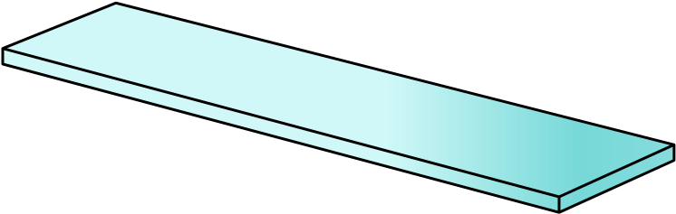

**Isocenter**

**Multi-Leaf**

**Collimator**

**Collimator angle**

**Gauntry angle**

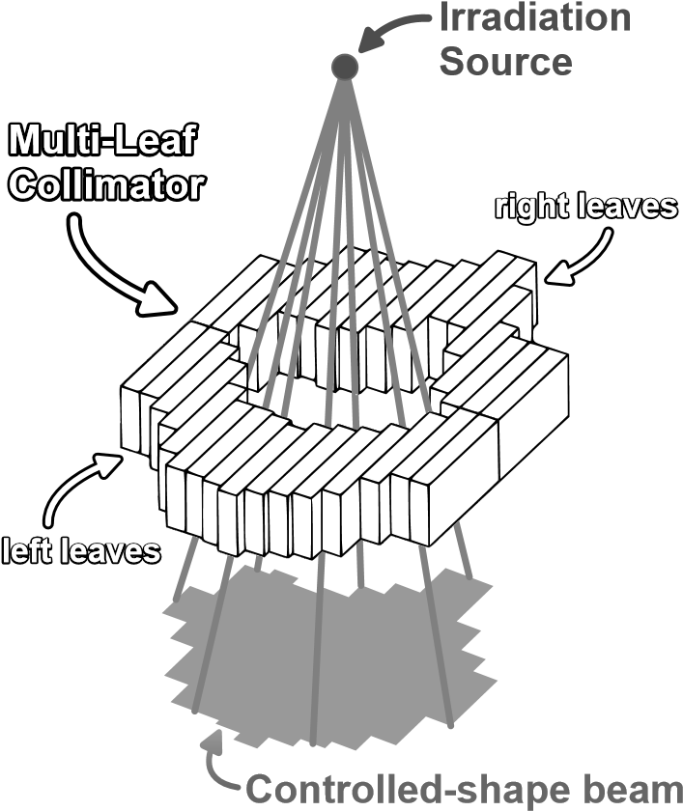

(b) Sketch of a Multi-Leaf Collimator

(a) Sketch of a Multi-Leaf Collimator. Filtering the Irradiation Source.

Figure 4: MLC-LINAC Machines Irradiation Filtering System.

for the three irradiation angles. Modern technology avoids single-use molds using motorized blockers to stop the rays and dynamically modulate the radiation beam.

## 5.2 Multi-Leaf Collimator - LINear ACcelerators

Multi-Leaf Collimator (MLC) technology combined with Linear Accelerators (LINAC) was a revolution in the radiotherapy world [BTK+13] [XLLJ17]. They are capable of turning around the patient to deliver irradiation from multiple angles ( gure 4a). Moreover, an array of motorized leaf pairs can shape the radiation beam with high precision ( gure 4b). Additionally, MLC systems are sometimes equipped with jaws, which help to shape the beams better. The MLC-LINAC is the most common type of radiation therapy machine used today. This manuscript will focus on the MLC-LINAC system due to its widespread use and versatility in clinical settings.

## 5.3 Tomotherapy

Tomotherapy systems have an irradiation head that rapidly rotates around the patient, equipped with a single layer of binary blockers that can be activated and deactivated almost instantaneously [MBR+99]. The tomotherapy machines follow a helical path [JMB+04], rotating around the patient while simultaneously moving along their body.

## 5.4 CyberKnife

CyberKnife systems are another non-invasive alternative to conventional MLC-LINAC radiotherapy machines with higher exibility [KND+20]. These CyberKnife machines have the irradiation head mounted on a robotic arm, which allows a vast array of motions around the patient. This exibility enables the delivery of even more complex-shaped doses. CyberKnife technology is particularly bene cial for treating unusual tumors in challenging or sensitive body areas.

## 5.5 Brachytherapy

Brachytherapy involves the placement of a radioactive source directly inside the body of the patient [CDB+19]. This technique allows for delivering localized high-dose radiation. Although brachytherapy involves an invasive procedure, it significantly minimizes radiation exposure to surrounding healthy tissues. The localized character of brachytherapy makes it a good treatment option for some types of cancer.

# 6 Irradiations techniques

This section describes the main irradiation techniques that can be used with MLC-LINAC machines. The techniques have evolved over the years of MLC usage. Better irradiation techniques improve tumor targeting while keeping exposure of healthy tissues to a minimum.

## 6.1 3-Dimensional Conformal Radiotherapy

Three-Dimensional Conformal Radiotherapy (3D CRT) shapes radiation beams to closely fit the contours of the tumor. The MLC leaves are positioned to match the tumor’s contour projection on a plane perpendicular to the radiation rays, typically using three angles. Such shaping of the beams can be done with mold (which is single-use) or with an MLC. Although 3D CRT targets the Principal Target Volume (PTV) more than Organs At Risk (OARs), modern techniques provide superior sparing of healthy tissues. Consequently, advanced and less naive methods have largely supplanted 3D CRT in contemporary clinical practice.

## 6.2 Intensity Modulated RadioTherapy

Intensity Modulated RadioTherapy (IMRT) represents a significant advancement over 3D CRT by taking better advantage of the MLC capabilities. Instead of delivering radiation with uniform intensity from each angle, IMRT dynamically adjusts the beam intensity to improve patient outcomes [MT00].

Number of Beams The choice of the number of beams in IMRT is a balance between treatment complexity and effectiveness. Using many beams can evenly spread the unwanted dose across all organs, but adds complexity to treatment planning and prolongs the delivery time, which can increase patient movement and reduce dose precision. Conversely, fewer beams simplify planning and shorten treatment time but may result in less optimal dose distribution. Research indicates that 50 beams are needed for "nearly optimal IMRT" [FPM11]. Beams at exactly 180 degrees from each other tend to have (very) similar influence on the dose distribution on the patient. Therefore, dosimetrists tend to choose an odd number of equispaced beams. In practice, the number of beams used is below 25.

## 6.3 Volumetric Modulated ArcTherapy

Volumetric Modulated Arc Therapy (VMAT) enhances IMRT by allowing the MLC LINAC head to rotate while delivering radiation. Unlike IMRT, which stops the head at specific positions around the patient, VMAT continuously irradiates while rotating. This technique can better distribute the unwanted dose and reduces the irradiation time [HTF+11].

However, the mechanical constraints of the machine complicate the optimization problem for VMAT compared to IMRT, making the optimization more computationally intensive. Studies have demonstrated that IMRT with a Sliding Window and more than 7 angles can achieve equally effective dose distribution [Bor09] [QLL+12]. While demonstrated with IMRT Sliding Window, the techniques developed in this manuscript apply to VMAT, given suficient computational resources.

# 7 Dosimetry steps

Dosimetry aims to design a treatment plan (i.e., machine instructions) that delivers the best possible dose for the patient. The "best" dose is difficult to define, so doctors formulate high-level clinical dose requirements. These requirements are abstract, so transitioning to machine instructions requires a series of sub-steps. For IntensityModulated Radiation Therapy (IMRT), three main steps are typically followed: Beam Orientation Optimization (BOO), Fluence Map Optimization (FMO), and Leaf Sequencing (LS).

## 7.1 Beams Orientation Optimization

Beam Orientation Optimization (BOO) is the initial dosimetry step. This step determines the optimal number of radiation beams and their respective angles. The beams’ orientation significantly impacts the dose distribution within the patient: beams close to each other tend to have similar effects on the body. In contrast, far-apart beams tend to create doses impacting different tissues in the body. There is one exception to this rule of thumbs: Beams

Optimal fluence map Level sets of fluence map

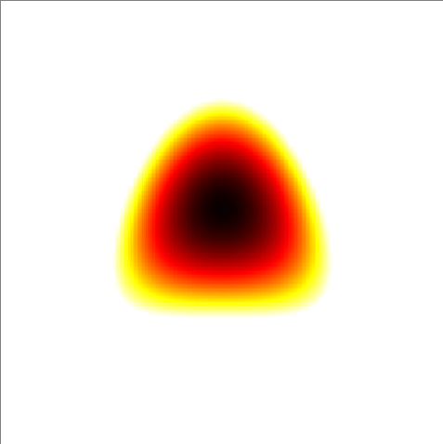

Figure 5: Example of a fluence map discretization

exactly 180 from each other can have a similar biological effect because rays will follow the same line, just entering the body from opposite directions. Despite its importance, the practical benefits of BOO are questionable. Research [RDV+19] suggests that an extensive BOO process offers only slight improvement over more straightforward strategies, like using equispaced beam angles. When using equispaced beams, it’s common to use an odd number of beams to avoid beams at exactly 180 having the same effect. Employing an odd number of beams is standard practice when utilizing equispaced beam arrangements. This approach avoids beams positioned at precisely 180 from each other, with similar clinical effects (as mentioned before). Therefore, this manuscript will assume the use of an odd number of equispaced beams and no further BOO.

## 7.2 Fluence Map Optimization

Fluence Map Optimization (FMO) is the critical step in the IMRT planning process. FMO aims to create fluence maps, i.e., a two-dimensional radiation intensity distribution on each beam’s cross-sectional area. The fluence maps should be optimized to shape the dose distribution according to the treatment plan’s objectives. At this stage, the physical constraints of the MLC still need to be considered; the primary focus is on achieving the desired dose distribution within the patient. The output of FMO is a set of idealized fluence maps for each beam.

## 7.3 Leaf Sequencing

Leaf Sequencing (LS) determines the specific positions and movements of the MLC leaves. The objective is to ensure that the delivered fluence map closely approximates the ideal fluence map generated during the Fluence Map Optimization (FMO) step. This approximation must be attained while considering the physical limitations of the treatment machine, such as irradiation power, leaf speed, or collimator speed, along with a soft constraint on the total treatment duration.

**Step and Shoot** The "Step and Shoot" technique in IMRT involves sequentially moving the MLC leaves to different positions to deliver varying radiation intensities. This technique for leaf sequencing is relatively simple computationally.

The fluence maps are divided into discrete levels (figure 5). Then, the MLC leaves are positioned so that the open area of the irradiation head matches the level set (figure 6). Note that convex level sets can all be matched with the MLC leaves; if the level set is concave, changing the collimator angle may allow the leaves to match the level set shape (figures 7a, 7b, 7c). Each level set is delivered as a static beam in sequence. As the level sets are refined, the irradiation time increases Dosimetrists must set a tradeo between achieving greater accuracy and maintaining an efficient treatment time.

**Sliding Window** The "Sliding Window" technique employs a continuous sweep motion of the MLC leaves. This approach enables the delivery of any continuous, positively defined fluence within the irradiation window of the MLC-LINAC. In contrast with step and shoot, a sliding window is more computationally intensive: Finding the appropriate leaf motions requires solving a linear programming problem for each pair of leaves (sometimes called "Inverse Sliding Window Algorithm").

The uence is segmented in a one-dimensional uence curve along each leaf pair axis (see gure 8). Suppose

Leaves positions

Level set 1

Level set 2

Level set 3

Level set 4

Figure 6: Example of level set matching with leaves.

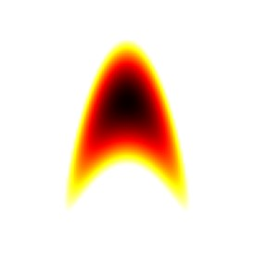

Optimal fluence map

Colimator angle: 0°

Colimator angle: 90°

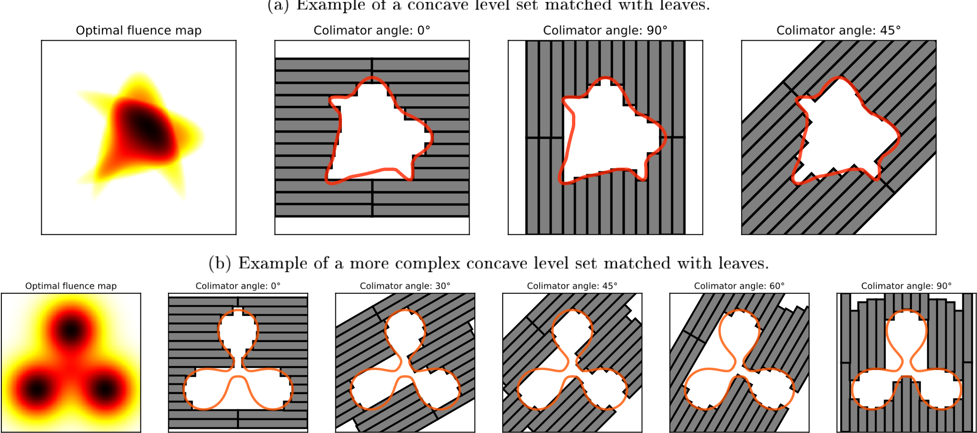

(c) Example of a concave level set impossible to match with leaves.

Figure 7: MLC leaves can not always be set to shape level sets of uence functions.

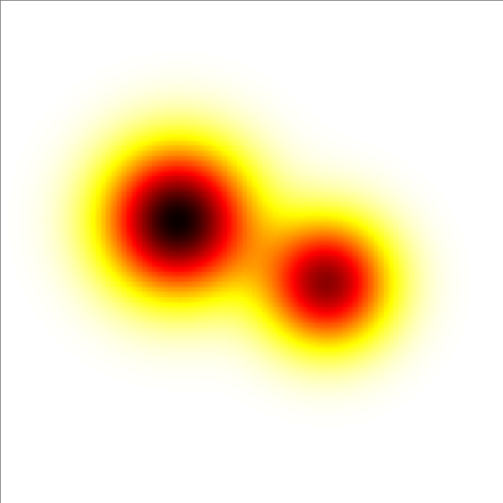

*x*

*y*

Optimal fluence map

Fluence

Fluence curve on

*y*

=0

Figure 8: Example of a uence map segmentation along a leaf pair axis.

the motion of the leaves is from left to right: The di erence between the time the right and left leaves pass by a point determines the amount of irradiation delivered at that point. The greater the time di erence, the more rays will be sent from that point (in gure 9a and 9b, the time laps between left and right leaves passing a point is proportional to the uence delivered at that point). One needs to carefully move the opening (right) and closing (left) leaves to deliver the correct amount of rays at each point of the uence map. Solving a linear programming problem allows a leaf pair to deliver any uence within arbitrary approximation in a reasonable amount of time ( gure 9). A playground to calculate the leaf’s motion for an arbitrary uence is available here: [https://mics-lab.github.io/PresentationJuin2023PRFD/demo.](https://mics-lab.github.io/PresentationJuin2023PRFD/demo)

The sliding window technique is used most of the time, as delivery time is much (about twice) faster [NG]. This manuscript assumes the use of this technique, focusing on optimizing the uence distribution.

## 7.4 (Optional) Direct Aperture Optimization

Direct Aperture Optimization is mainly used in VMAT and occasionally employed to enhance IMRT plans. Unlike traditional approaches, which separate uence map optimization from leaf sequencing, DAO directly optimizes the motion of the MLC leaves.

In VMAT, applying conventional leaf sequencing to any arbitrary uence map is not feasible. Therefore, DAO is essential, as it is the only optimization method capable of generating a VMAT treatment plan.

When applied to IMRT, DAO can re ne the treatment plan by directly adjusting the aperture shapes to better align with the desired dose distribution while accounting for the physical constraints of the treatment machine. However, as this manuscript is not focused on leaf sequencing, it assumes that no additional DAO is applied following conventional leaf sequencing.

# 8 Simulation

Throughout the dosimetry process, several approximations are employed. First, the assumption is that each bixel (beam pixel) operates independently. This approximation fails to account for interactions between adjacent bixels. Additionally, during FMO, ideal uence maps are generated without considering the physical limitations of the treatment machine, such as the width of the multi-leaf collimator (MLC) leaves (often 5 mm). Furthermore, the e ects of beam penumbra and the scattering of radiation within the patient’s body are often simpli ed or neglected in the FMO. Given these approximations, re-simulation of the treatment plan is critical to verify that the machine instructions deliver a dose distribution closely aligned with the expected outcomes.

Fluence 10-pieces linear approximation

1. Example of a uence curve leaf sequencing, with the uence approximated by a 10-pieces linear function.

Fluence 100-pieces linear approximation

Time

Optimal leaves motion

Time

Optimal leaves motion

1. Example of a uence curve leaf sequencing, with the uence approximated by a 100-pieces linear function.

Figure 9: Fluence curve can be approximated with arbitrary error.

# 9 Treatment Planning Systems

Treatment Planning Systems (TPS) are the crucial tools that calculate the precise machine (MLC) motions according to the dosimetrists priorities and the irradiation technique chosen.

## 9.1 Manufacturer

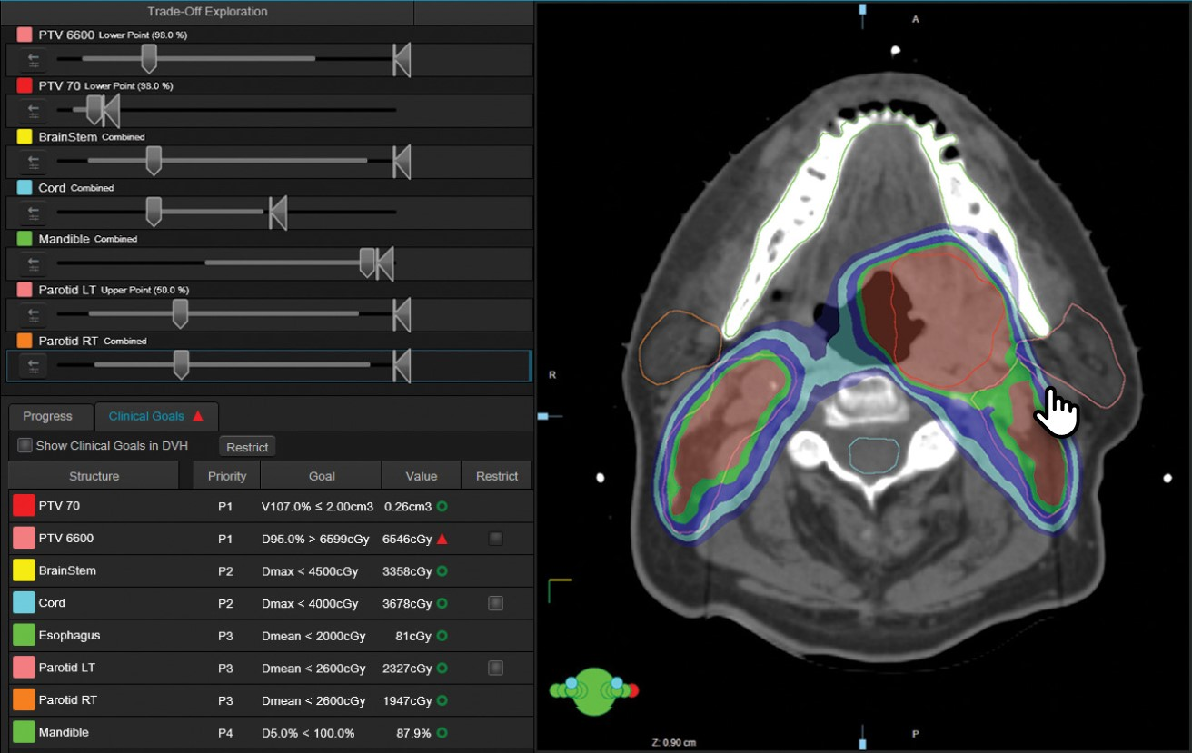Eclipse (Varian)

Eclipse [Var24], developed by Varian, is one of the most widely used TPS globally. It supports VMAT with one or multiple arcs, and IMRT with any number of beams. Eclipse integrates with Varian’s suite of treatment machines, and integrates an automatic contouring tool [Var].

Advertisement screenshot of Eclipse (Varian’s TPS).

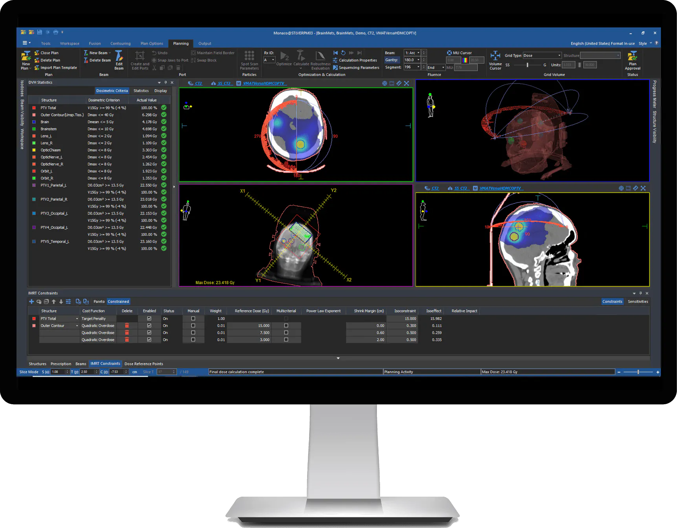ONEfi | Planning (Elekta)

ONEfi | Planning [Ele24] is Elekta’s TPS, and is also widely used, supporting IMRT and VMAT. It is renowned for its speed with high-precision dose calculation using the Monte Carlo method.

Advertisement screenshot of

ONEfi | Planning (Elekta’s TPS).

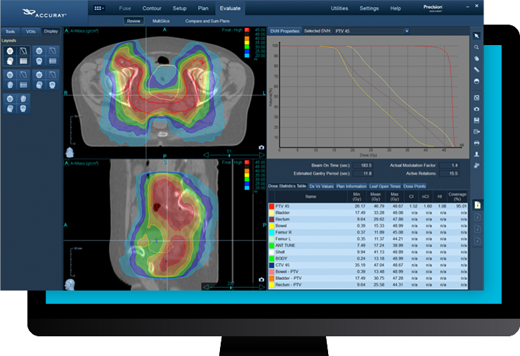Precisionfi (Accuray)

Developed by Accuray, Precisionfi [Acc24] is the dedicated TPS for CyberKnife and TomoTherapy systems.

Advertisement screenshot of Precisionfi (Accuray’s TPS).

## 9.2 Non-manufacturer

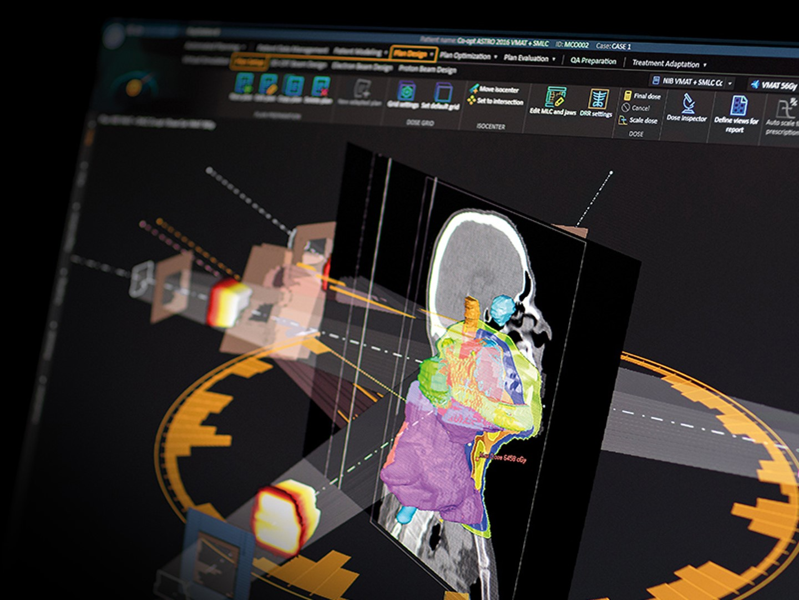RayStation (RaySearch)

|  |  |  |
| --- | --- | --- |
| [Acc24] | Accuray. Precisionfi, 2024. |  |
| [Bee52] | Beer. Bestimmung der absorption des rothen lichts in farbigen 162(5):78 88, 1852. | ssigkeiten. Annalen der Physik, |

RayStation [Lab24], developed by RaySearch Laboratories, is a TPS known for its advanced optimization algorithms. Unlike manufacturer-speci c systems, RayStation can output plans for a wide range of linear accelerators and imaging devices. It o ers robust support for various treatment techniques, including VMAT, IMRT, 3D-CRT, Cyberknife, and TomoTherapy.

Advertisement screenshot of

RayStation (RaySearch’s TPS).

matRad (German Cancer Research Center - DKFZ) matRad [DKF24] is an open-source TPS developed by the German Cancer Research Center (DKFZ) for research and education. While not intended for clinical use, matRad o ers a exible platform for testing and developing new treatment-planning algorithms.

AutoPlan (TheraPanacea - Unpublished)

AutoPlan is the upcoming TPS from TheraPanacea, designed to incorporate arti cial intelligence and machine learning into the treatment planning process.

# References

|  |  |
| --- | --- |
| [Bor09] | Thomas Bortfeld. The number of beams in imrt theoretical investigations and implications for single-arc imrt. Physics in Medicine & Biology, 55(1):83, nov 2009. |
| [BTK+13] | Erjona Bakiu, Ervis Telhaj, Elvisa Kozma, Ferdinand Ru i, and Partizan Malkaj. Comparison of  3d crt and imrt tratment plans. Acta informatica medica: AIM: journal of the Society for Medical Informatics of Bosnia & Herzegovina: casopis Drustva za medicinsku informatiku BiH, 21(3):211 212, 2013. PMC3804479. |
| [CAG13] | Roger Chammas, Cell Adhesion, and Cancer Group. Tumors as complex organs: are cancers manageable through the modi cation of their microenvironment? BMC Proceedings, 7(2):K16, Apr 2013. |
| [can] | Stages of cancer. |
| [CBM99] | Elizabeth Cohen Jonathan, Eric J Bernhard, and W Gillies McKenna. How does radiation kill cells? Current Opinion in Chemical Biology, 3(1):77 83, 1999. |
| [CDB+19] | Cyrus Chargari, Eric Deutsch, Pierre Blanchard, Sebastien Gouy, HØlŁne Martelli, Florent GuØrin, Isabelle Dumas, Alberto Bossi, Philippe Morice, Akila N. Viswanathan, and Christine Haie-Meder. Brachytherapy: An overview for clinicians. CA: A Cancer Journal for Clinicians, 69(5):386 401, 2019. |
| [DKF24] | DKFZ. matrad, 2024. |
| [Ele24] | Elekta. Onefi | planning, 2024. |
| [Eva58] | Robley D. Evans. Compton E ect, pages 218 298. Springer Berlin Heidelberg, Berlin, Heidelberg, 1958. |
| [FPM11] | John D. Fenwick and Juan Pardo-Montero. Numbers of beam angles required for near-optimal imrt: Theoretical limits and numerical studies. Medical Physics, 38(8):4518 4530, 2011. |
| [HK20] | Hyun Do Huh and Seonghoon Kim. History of radiation therapy technology. Progress in Medical Physics, 31(3):124 134, Sep 2020. |
| [Hol95] | L R Holsti. Development of clinical radiotherapy since 1896. Acta Oncol, 34(8):995 1003, 1995. |
| [HTF+11] | Nicholas Hardcastle, Wolfgang A. TomØ, Kerwyn Foo, Andrew Miller, Martin Carolan, and Peter Metcalfe. Comparison of prostate imrt and vmat biologically optimised treatment plans. Medical Dosimetry, 36(3):292 298, 2011. |
| [HXL+21] | Haihua He, Tangpeng Xu, Ping Li, Guohua Jia, Xiangpan Li, and Qibin Song. Anti-pd-1 immunotherapy combined with stereotactic body radiation therapy and gm-csf as salvage therapy in a pd-l1-positive patient with refractory metastatic thyroid h rthle cell carcinoma: A case report and literature review. Frontiers in Oncology, 11, 2021. |
| [JDB] | Christian Wittekind James D. Brierley, Mary K. Gospodarowicz. TNM Classi cation of Malignant Tumours, 8th Edition. Wiey Blackwell, 8th (2016) edition. TNM Classi cation of Malignant Tumours eighth edition provides the latest, internationally agreed-upon standards to describe and categorize cancer stage. |
| [JMB+04] | Robert Jeraj, Thomas R. Mackie, John Balog, Gustavo Olivera, Dave Pearson, Je Kapatoes, Ken Ruchala, and Paul Reckwerdt. Radiation characteristics of helical tomotherapy. Medical Physics, 31(2):396 404, 2004. |
| [KCKM09] | Eric A. Klein, Jay Ciezki, Patrick A. Kupelian, and Arul Mahadevan. Outcomes for intermediate risk prostate cancer: Are there advantages for surgery, external radiation, or brachytherapy? Urologic Oncology: Seminars and Original Investigations, 27(1):67 71, 2009. Proceedings: Annual Meeting of the Society of Urologic Oncology/Society for Basic Urologic Research (May 2007). |
| [KND+20] | Warren Kilby, Michael Naylor, John R. Dooley, Calvin R. Maurer, and Sohail Sayeh. 2 - a technical overview of the cyberknife system. In Mohammad H. Abedin-Nasab, editor, Handbook of Robotic and Image-Guided Surgery, pages 15 38. Elsevier, 2020. |
| [Lab24] | RaySearch Laboratories. Raystation, 2024. |

|  |  |
| --- | --- |
| [MBR+99] | T. Rockwell Mackie, John Balog, Ken Ruchala, Dave Shepard, Stacy Aldridge, Ed Fitchard, Paul Reckwerdt, Gustavo Olivera, Todd McNutt, and Minesh Mehta. Tomotherapy. Seminars in Radiation Oncology, 9(1):108 117, Jan 1999. |
| [MT00] | Francois EschwŁge Maurice Tubiana. Conformal radiotherapy and intensity-modulated radiotherapy: Clinical data. Acta Oncologica, 39(5):555 567, 2000. PMID: 11093364. |
| [NG] | Liming XU Ning GE, Fuci CHEN. Comparison between sliding window and step and shoot. 6. |
| [NXS+17] | Toshiaki Nakano, Xu Xu, Amir M.H. Salem, Mahmoud I. Shoulkamy, and Hiroshi Ide. Radiationinduced dna protein cross-links: Mechanisms and biological signi cance. Free Radical Biology and Medicine, 107:136 145, 2017. Oxidative DNA Damage & Repair. |
| [QLL+12] | Enzhuo M. Quan, Xiaoqiang Li, Yupeng Li, Xiaochun Wang, Rajat J. Kudchadker, Jennifer L. Johnson, Deborah A. Kuban, Andrew K. Lee, and Xiaodong Zhang. A comprehensive comparison of imrt and vmat plan quality for prostate cancer treatment. International Journal of Radiation Oncology*Biology*Physics, 83(4):1169 1178, 2012. |
| [RDV+19] | Humberto Rocha, Joana Matos Dias, Tiago Ventura, Br gida da Costa Ferreira, and Maria do Carmo Lopes. Beam angle optimization in imrt: are we really optimizing what matters? International Transactions in Operational Research, 26(3):908 928, 2019. |
| [RKG85] | R Roots, G Kraft, and E Gosschalk. The formation of radiation-induced dna breaks: The ratio of double-strand breaks to single-strand breaks. International Journal of Radiation Oncology*Biology*Physics, 11(2):259 265, 1985. |
| [Sch14] | G. Scholes. Radiation e ects on dna. the silvanus thompson memorial lecture, april 1982. British Journal of Radiology, 56(664):221 231, 05 2014. |
| [Som00] | Z. Somosy. Radiation response of cell organelles. Micron, 31(2):165 181, 2000. |
| [Ste06] | Patricia S Steeg. Tumor metastasis: mechanistic insights and clinical challenges. Nat. Med., 12(8):895 904, aug 2006. |
| [THLSM+13] Juliette Thariat, Jean-Michel Hannoun-Levi, Arthur Sun Myint, Te Vuong, and Jean-Pierre GØrard. Past, present, and future of radiotherapy for the bene t of patients. Nature Reviews Clinical Oncology, 10(1):52 60, Jan 2013.  [Var] Varian. Eclipse treatment planning system. Online.  [Var24] Varian. Eclipse 2024.  [VBPW+15] Claire Vanpouille-Box, Karsten A. Pilones, Erik Wennerberg, Silvia C. Formenti, and Sandra Demaria. In situ vaccination by radiotherapy to improve responses to anti-ctla-4 treatment. Vaccine, 33(51):7415 7422, 2015.  [WHCI20] Richard C. Walshaw, Jamie Honeychurch, Ananya Choudhury, and Timothy M. Illidge. Toll-like receptor agonists and radiation therapy combinations: An untapped opportunity to induce anticancer immunity and improve tumor control. International Journal of Radiation Oncology*Biology*Physics, 108(1):27 37, 2020. Radiation Therapy and the Immune Response.  [who] Global cancer burden growing, amidst mounting need for services.  [WSY10] Esther Witsch, Michael Sela, and Yosef Yarden. Roles for growth factors in cancer progression. Physiology, 25(2):85 101, 2010. PMID: 20430953.  [WWQ18] Jin-Song Wang, Hai-Juan Wang, and Hai-Li Qian. Biological e ects of radiation on cancer cells. Mil. Med. Res., 5(1), dec 2018.  [XLLJ17] Dandan Xu, Guowen Li, Hongfei Li, and Fei Jia. Comparison of imrt versus 3d-crt in the treatment of esophagus cancer. Medicine, 96(31):e7685, Aug 2017. | |